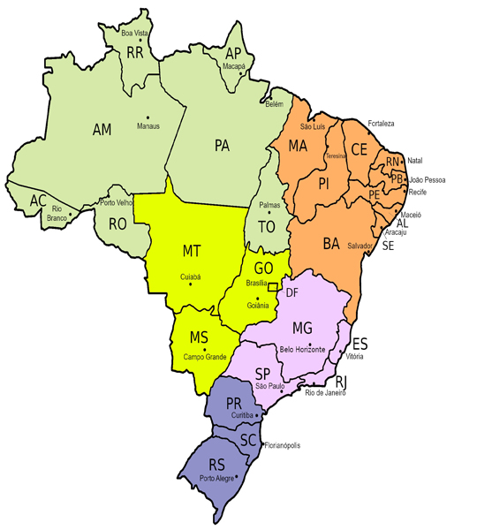
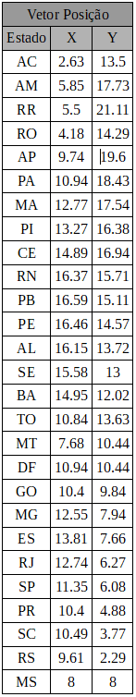

Matriz Adjacência

A = [0 1 0 1 0 0 0 0 0 0 0 0 0 0 0 0 0 0 0 0 0 0 0 0 0 0 0;
1 0 1 1 0 1 0 0 0 0 0 0 0 0 0 0 0 0 0 0 0 0 0 0 0 0 0;
0 1 0 0 0 1 0 0 0 0 0 0 0 0 0 0 0 0 0 0 0 0 0 0 0 0 0;
1 1 0 0 0 0 0 0 0 0 0 0 0 0 0 0 1 0 0 0 0 0 0 0 0 0 0;
0 0 0 0 0 1 0 0 0 0 0 0 0 0 0 0 0 0 0 0 0 0 0 0 0 0 0;
0 1 1 0 1 0 1 0 0 0 0 0 0 0 0 1 1 0 0 0 0 0 0 0 0 0 0;
0 0 0 0 0 1 0 1 0 0 0 0 0 0 0 1 0 0 0 0 0 0 0 0 0 0 0;
0 0 0 0 0 0 1 0 1 0 0 1 0 0 1 1 0 0 0 0 0 0 0 0 0 0 0;
0 0 0 0 0 0 0 1 0 1 1 1 0 0 0 0 0 0 0 0 0 0 0 0 0 0 0;
0 0 0 0 0 0 0 0 1 0 1 0 0 0 0 0 0 0 0 0 0 0 0 0 0 0 0;
0 0 0 0 0 0 0 0 1 1 0 1 0 0 0 0 0 0 0 0 0 0 0 0 0 0 0;
0 0 0 0 0 0 0 1 1 0 1 0 1 0 1 0 0 0 0 0 0 0 0 0 0 0 0;
0 0 0 0 0 0 0 0 0 0 0 1 0 1 1 0 0 0 0 0 0 0 0 0 0 0 0;
0 0 0 0 0 0 0 0 0 0 0 0 1 0 1 0 0 0 0 0 0 0 0 0 0 0 0;
0 0 0 0 0 0 0 1 0 0 0 1 1 1 0 1 0 0 1 0 1 0 0 0 0 0 0;
0 0 0 0 0 1 1 1 0 0 0 0 0 0 1 0 1 0 1 0 0 0 0 0 0 0 0;
0 0 0 1 0 1 0 0 0 0 0 0 0 0 0 1 0 0 1 0 0 0 0 0 0 0 1;
0 0 0 0 0 0 0 0 0 0 0 0 0 0 0 0 0 0 1 0 0 0 0 0 0 0 0;
0 0 0 0 0 0 0 0 0 0 0 0 0 0 0 0 1 1 0 1 0 0 0 0 0 0 1;
0 0 0 0 0 0 0 0 0 0 0 0 0 0 0 0 0 0 1 0 1 1 1 0 0 0 0;
0 0 0 0 0 0 0 0 0 0 0 0 0 0 1 0 0 0 0 1 0 1 0 0 0 0 0;
0 0 0 0 0 0 0 0 0 0 0 0 0 0 0 0 0 0 0 1 1 0 1 0 0 0 0;
0 0 0 0 0 0 0 0 0 0 0 0 0 0 0 0 0 0 0 1 0 1 0 1 0 0 1;
0 0 0 0 0 0 0 0 0 0 0 0 0 0 0 0 0 0 0 0 0 0 1 0 1 0 1;
0 0 0 0 0 0 0 0 0 0 0 0 0 0 0 0 0 0 0 0 0 0 0 1 0 1 0;
0 0 0 0 0 0 0 0 0 0 0 0 0 0 0 0 0 0 0 0 0 0 0 0 1 0 0;
0 0 0 0 0 0 0 0 0 0 0 0 0 0 0 0 1 0 1 0 0 0 1 1 0 0 0;]

